**SONAR PROJECT**

First I loaded all the required libraries such as numpy, panda, matplotlib etc.

Then I imported the dataset with read_csv command. Then I took out the shape of the data using the command data.shape. Then I looked out for the data types present in the datasheet. Then I took out the histograms of the present data alongwith the density of the dataset which looked like this

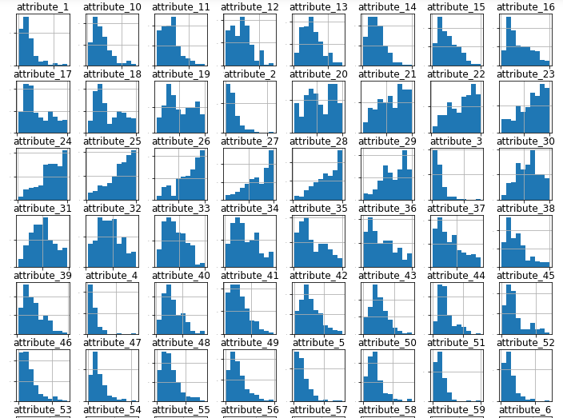

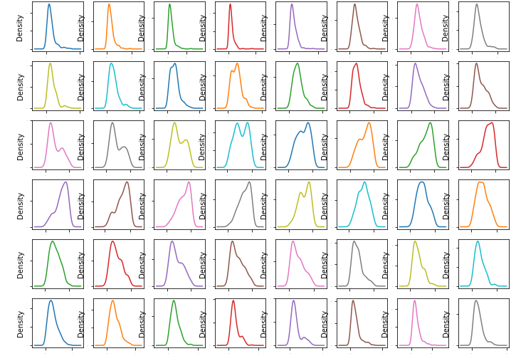

Then I found out the correlation matrix. Then I split out the validation dataset.

Then I compared the algorithms and standardized the dataset. Then I compared the scaled algorithms in which I found out the the KNN and SVM shows the most promising options.

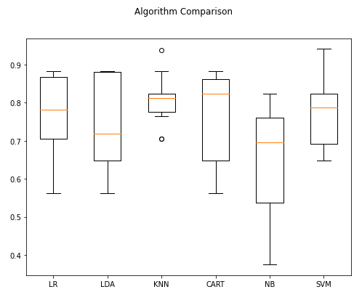

After both the algorithm tuning SVM is proving the best with accuracy of 86.7% over KNN's best of 84.9%. But KNN seemed to indicate a tighter variance during spot checking. I tried some ensemble methods. No standardization on data this time. Because apparently all four ensembles we are using are based on decision trees and thus are less sensitive to data distributions.

SVM shows a lot of promise as a low complexity and stable model for this problem. The accuracy on the validation set was 85.7%.